ASSIGNMENT 2: VAISHNAVI R(111519106164)

Build a python code by assumming temperature and humidity values using random function .And write a condition to continuously buzz an alarm in case of high temperature.

CODE:

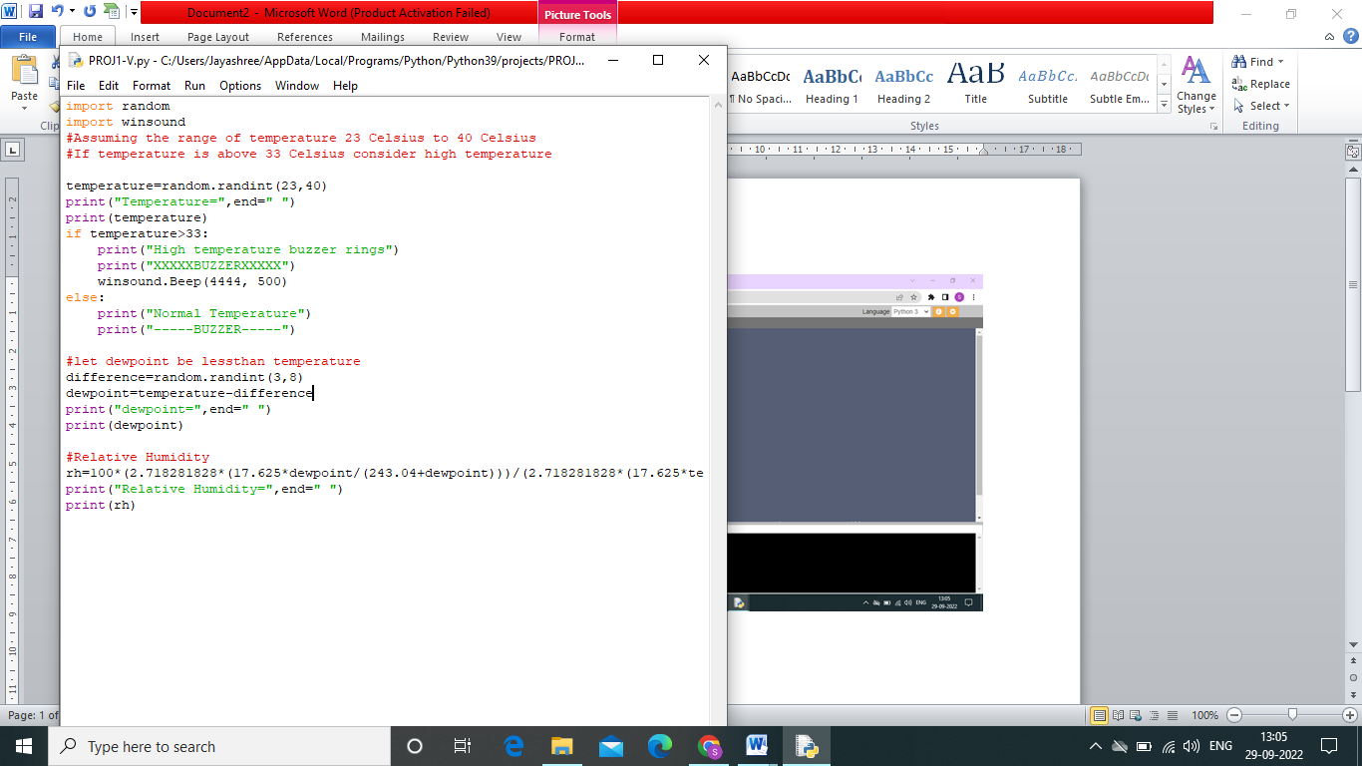

OUPUT:

